 ơ–

**FPT ACADEMY INTERNATIONAL**

**FPT – APTECH COMPUTER EDUCATION**

Centre name: ACE-HCMC-2-FPT

Address: 590 Cach Mang Thang Tam, ward 11, district 3, Ho Chi Minh city

Dog shop

Design document

|  |  |  |
| --- | --- | --- |
| **Supervisor** | Nguyễn Hạ Vy | |
| **Batch** | T1.2208.A2 | |
| **Group** | 2 | |
| **Serial No.** | **Student Name** | **Enrollment Number** |
| 1. | Trương Tấn Phát | Student1409158 |
| 2. | Nguyễn Hoàng Gia Phúc | Student1408029 |
| 3. | Nguyễn Trọng Tiến Đức | Student1409132 |
| 4. | Diệp Thái Thiên Long | Student1409154 |

**June – 2023**

**This is to certify that**

**Mr./Ms.:**

**Trương Tấn Phát**

**Nguyễn Hoàng Gia Phúc**

**Nguyễn Trọng Tiến Đức**

**Diệp Thái Thiên Long**

**Has successful design & developed:**

Project: Dog shop

**Submitted by:** Nguyễn Hạs Vy

**Date of issue:** June – 2023

**Authorized Signature****:**

# **ACKNOWLEDGEMENT**

We would like to dedicate this section to express our deepest gratitude to all those who have been with us and provided invaluable support throughout the course of this Project.

First and foremost, we would like to sincerely thank Ms. Nguyen Ha Vy - our dedicated mentor. She not only shared valuable advice but also encouraging us to overcome the technological and psychological challenges we faced.

Second, we appreciate the Project team at the Headquarters for providing us with a precious opportunity to apply the knowledge we have acquired to practical situations. We firmly believe that the experiences gained from this Project will contribute positively to our future development. We would also like to extend our gratitude to all the staff members at the center who not only gave us the chance to work with them on this Project but also supported and encouraging us throughout the process.

Finally, we want to express our special thanks to our dear classmates and team members who have always been open-minded and enthusiastic in supporting us. Your unity and commitment have led to the success of this Project.

# 

# **REVIEW 1**

## **INTRODUCTION**

In the era of information technology and computers, people can do anything at home, just connect to the internet and use online services. So we are developing a vegetable ordering website called Dog Shop.

“Dog Shop” is a group of people who want to develop an app where users can order in conjunction with online payments and shippers can deliver the goods once completed.

**For Dog Shop Online’s customers:**

• User-friendly web interface.

• View product information.

• Offer a variety of dog breeds to suit a wide range of customer preferences.

• Top selling items.

• Top new items updated.

• Specific information, details of each product, classified by category, ...

• Find product information easily.

• Allow customers to register, log in and ensure customer information security (Spring Security)

• Add cart, order quickly

• Pay for shipping code

• Pay online with paypal

• Send interactive emails with customers

**For Dog Shop System’s Admin:**

## Order reporting, order viewing and order confirmation,.

## Manage information related to products, categories, customers,.

* Export order excel file

## PROBLEM DEFINITION

With a passionate love for dogs, our team decided to create a pet website to provide people with a reliable and convenient platform to find and buy their favorite pets. . Before we embarked on the idea, we held panel sessions to discuss important issues and ensure that we could meet the market's requirements.

During the discussion, we posed some important questions that we needed to address in order to get the best results, such as:

1. How can the admin login?
2. How does the admin manage order?
3. How does the admin manage revenue?
4. How does the admin manage employee?
5. How does the admin manage shipper’s account?
6. How does the admin change the proccess?

## CUSTOMER REQUIREMENT SPECIFICATION

**Business/Project Objective:** The project is to design for ordering dog.

1. **Functional Requirement:**

**Input to the system:**

**Administrators need to provide:**

REQ.1: Provide a price for one dog.

**Visitors need to provide:**

REQ.1: Personal information to create an account.

**Output from the system:**

**Administrators will be able to:**

REQ.1: Login to the admin system.

REQ.2: Manage order.

REQ.3: Export report.

REQ.4: Manage employee’s account

REQ.5: Manage proccess (new, received, processing, done,...).

REQ.6: Calculate shipper’s sale Visitors will be able to:

6.1: If visitors are guests:

See pages in the app.

Register.

6.2 If visitors are registered:

Order package.

See order’s history.

Feedback.

1. **Non-Functional Requirement:**

REQ.1: Notification by email.

REQ.2: A chat box.

## 

## SCOPE OF WORK

The application must perform the following functions:

**Login:**

* There are 2 types of accounts in the application (“administrator” and “user”). The Administrator will login as “admin” on the website and the Customer will log in as the “user”.
* Two accounts must be logged in to use the app's functionality.
* For “administrators”: can change the order processing process.
* For “users”: register a new account.

**Transport:**

* When customers order online, someone will deliver to pick up. After the package has been processed, the delivery person will deliver it to the customer's home.

**Database**

* The information about customer, order, shipper will be stored in the database.

## SYSTEM REQUIREMENT SPECIFICATION

**Hardware:**

* + - 1. Web server:

|  |  |
| --- | --- |
| Processor | Intel Core i5 or higher. |
| Memory | 128 Megabytes of RAM or better. |
| Modem/ADSL | Connecting to internet 24/24 |

* + - 1. Client:

|  |  |
| --- | --- |
| Processor | Intel Core i3 or higher. |
| Memory | 128 Megabytes of RAM or better. |
| Modem/ADSL | Connecting to internet |

**Software:**

1. Web server:

|  |  |
| --- | --- |
| Operation System | Windows 7 or higher |
| Browser | Chrome version 35 or better |
| Database | MySQL |
| Software | IntelliJ IDEA |

2. Client:

|  |  |
| --- | --- |
| Operation System | Windows 7 or higher |
| Browser | Chrome version 35 or better |
| Database | MySQL |
| Software | IntelliJ IDEA |

**Technology:**

|  |  |
| --- | --- |
| Frontend | HTML5, CSS, Jquery 3.4.1 |
| Javascript 1.5 |
| Bootstrap 5 |
| Backend | API |
| QR Code |
| Java |
| Springboot |
| Android |
| Tomcat |
| GSON |

# TASK SHEET REVIEW 1

|  |  |  |  |  |  |  |  |
| --- | --- | --- | --- | --- | --- | --- | --- |
| **Project Ref. No** | | **Project Title:** | **Activity Plan Prepared By:** | **Date of Preparation of Activity Plan:** | | | |
| **Sr.No.** | **Task** | **Actual Start Date** | **Actual Days** | **Team Mate Names** | **Status** |
| 1 | Introduction and Problem Definition | Dog shop Online | Trương Tấn Phát | 12/06/2023 | 1 | - Nguyễn Hoàng Gia Phúc  - Nguyễn Trọng Tiến Đức  - Diệp Thái Thiên Long | 100% |
| 2 | Customer Requirement Specification (CRS) | 12/06/2023 | 1 | 100% |
| 3 | Functional Requirement | 12/06/2023 | 1 | 100% |
| 4 | System Requirement Specification |
| 12/06/2023 | 1 | 100% |
| 5. | Scope Of Work | 12/06/2023 | 1 | 100% |

|  |  |
| --- | --- |
| **Date: 12/06/2023** | |
| Signature of Insstructor:  **Mr. Nguyen Ha Vy** | Signature of Team Leader:  **Trương Tấn Phát** |

# **REVIEW 2**

## Architecture Project

`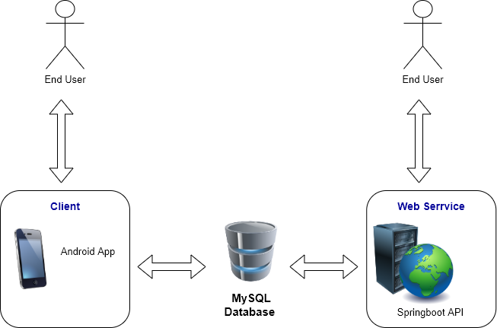

## DATA FLOW DIAGRAM (DFD)

1. **Context level:**

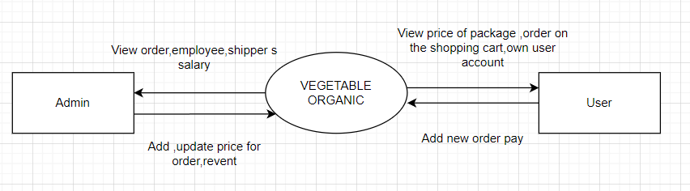

1. **The first level of DFD:**

1. Customer:

Level 0:

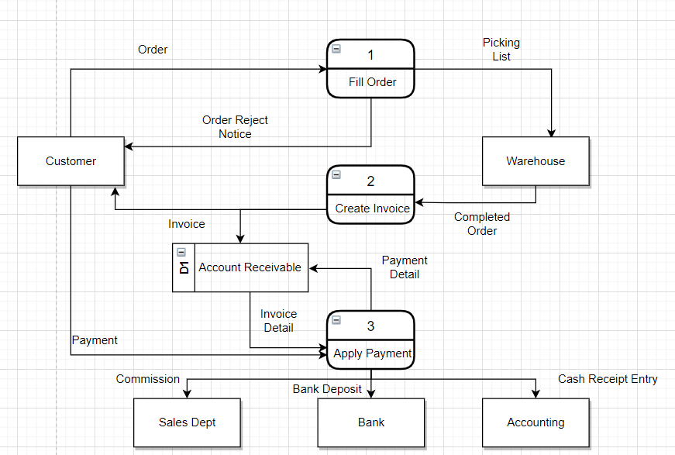

Level 1:

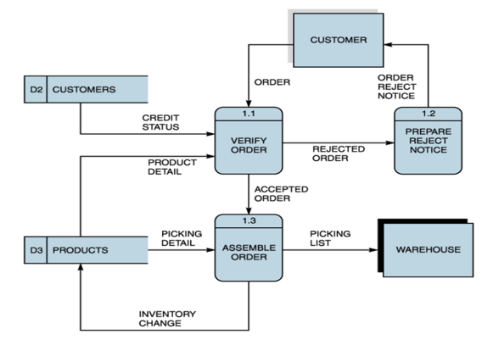

Fig 1.1 Fill Order

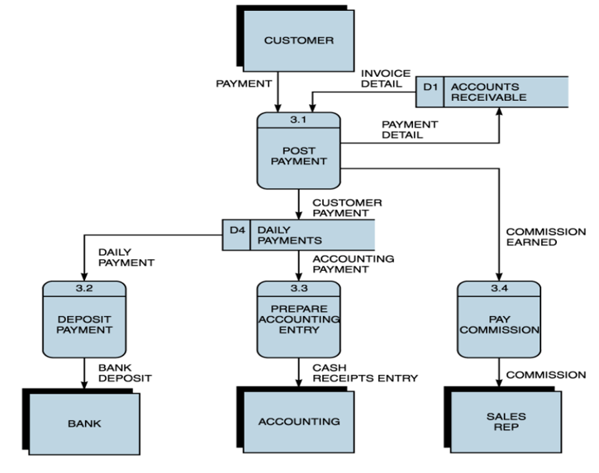

Fig 1.2 Apply Payment

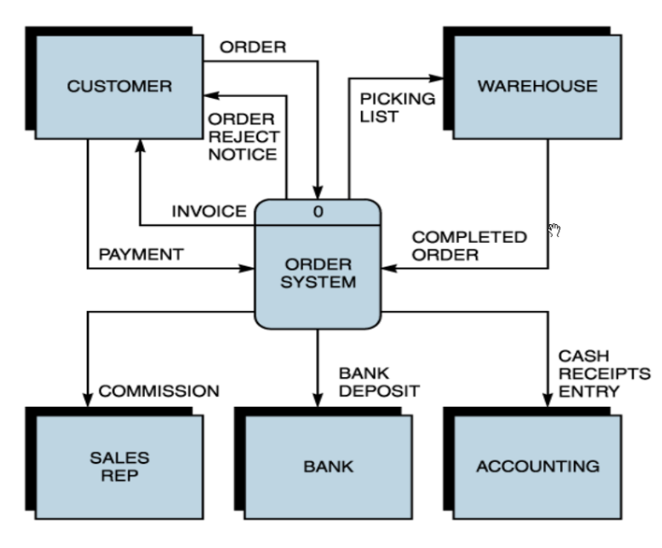

Fig 1.3 Ordering System

2. Admin:

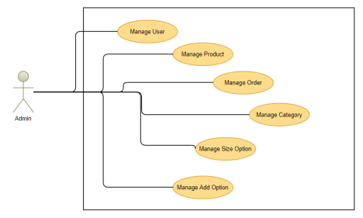

## USE CASE DIAGRAM AND SEQUENCE DIAGRAM

**1.Visitor(Customer):**

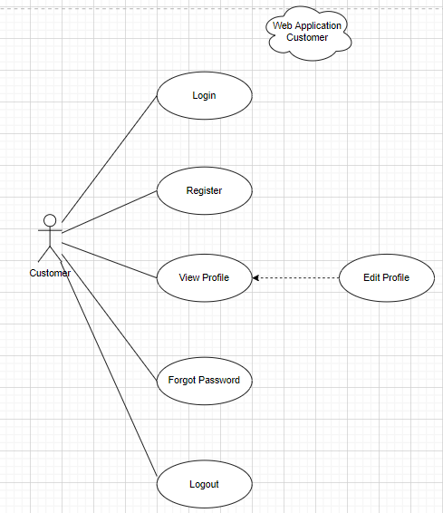

* Sign Up:

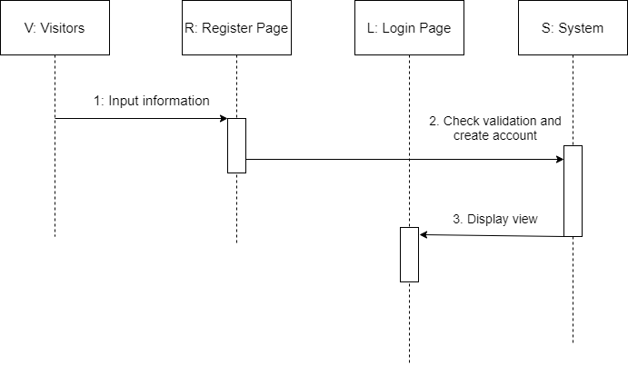

|  |  |  |
| --- | --- | --- |
| **Description** | When visitors enter information and click on register button, Vegetable Organic system will create new account | |
|  | **Action** | **System responses** |
| **Basic flow** | 1) Input information | When visitor enters the Register page, the registration form will appear to register. After the form is displayed, the visitors enter their information. |
| 2) Check validation and create account | After the visitor enters the information, the system will check, if all the information is correct, the system will create an account for the user. |
| 3) Display view | If the account is created successfully, the system will display a Login page for user to sign in. |
| **Exception** | Username field blank  Username min length  Password field blank  Password min length  Password pattern | Display error message  “Username can not blank”  “Username must be larger than 3 characters”  “Password can not blank”  “Password must be larger than 3 characters”  “Password must not contain special characters” |

* Sign Up Gmail, Facebook:

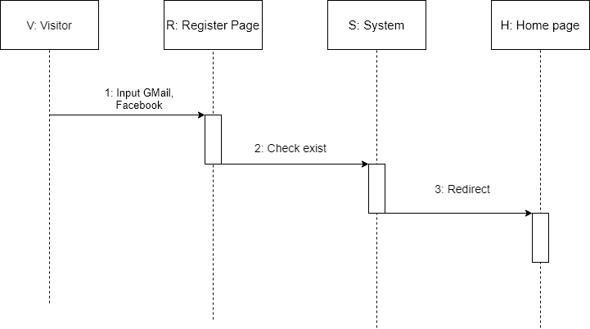

|  |  |  |
| --- | --- | --- |
| **Description** | When visitors use Facebook, Gmail. Vegetable Organic system will create new account | |
|  | **Action** | **System responses** |
| **Basic flow** | 1) Input Gmail, Facebook | When visitor enters the Register page, the Facebook, Gmail buttons will appear to register. |
| 2) Check exist | Vegetable Organic system will check, if the account exists, it will log in to the system, if the account doesn’t exist, it will create. |
| 3) Redirect | After create successfully, it will return to Home page. |
| **Exception** |  |  |

Login:

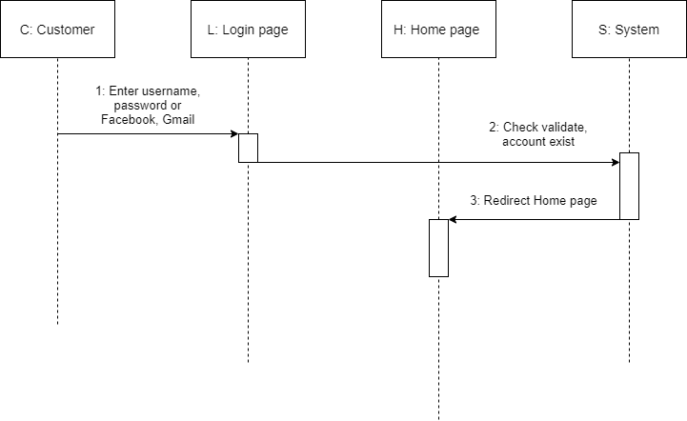

Create an order:

|  |  |  |
| --- | --- | --- |
| **Description** | When the user starts ordering, the order form will appear for the customer to fill in the information, dog shop system will create an order. | |
|  | **Action** | **System responses** |
| **Basic flow** | 1) Input item (available category), Input quantity | When you want to place an order, customers only need to enter the quantity they want to buy and the service they want, as well as select the types of items to order. |
| 2) View information | Sau khi nhập số lượng muốn mua và thanh toán, chi tiết đơn hàng sẽ được hiển thị. |
| 3) Create order and order detail | If the customer can cancel the order if there is a reasonable reason, the Dog Shop system will cancel the order. |
| **Exception** |  |  |

Payment:

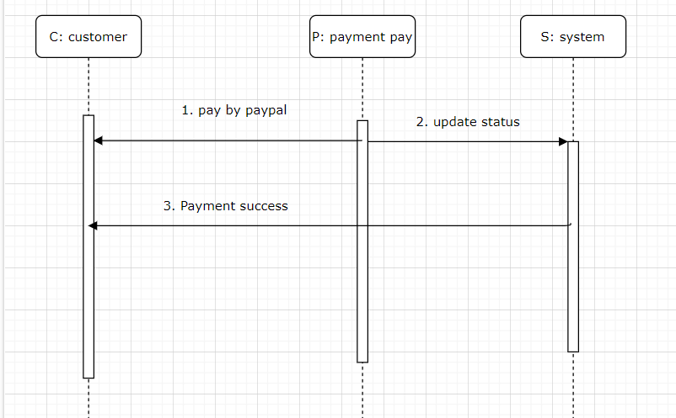

|  |  |  |
| --- | --- | --- |
| **Description** | Once the order is created, the user will receive an email for payment | |
|  | **Action** | **System responses** |
| **Basic flow** | 1. pay by paypal | Customer pays and confirm payment. |
| 2. update status | After the customer confirm the payment, the system will update the status of the order. |
| 3. Payment success | Customer will receive a successful payment notification after completing the process. |
| **Exception** |  |  |

**2.Admin:**

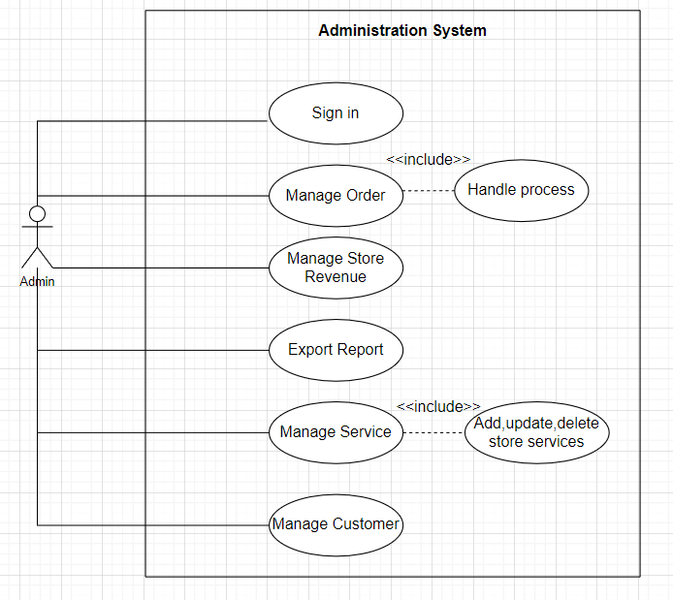

* Sign in:

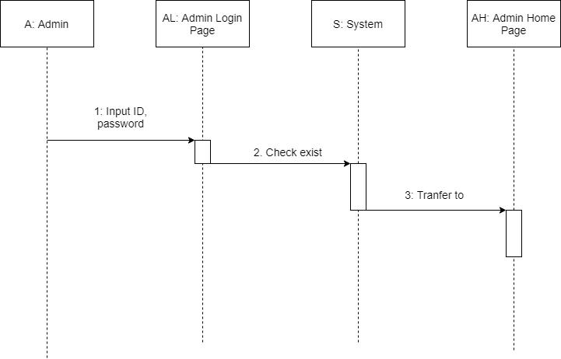

|  |  |  |
| --- | --- | --- |
| **Description** | Admin log in after the system checks, it will let you in. | |
|  | **Action** | **System responses** |
| **Basic flow** | 1) Input ID, password | Admin enters ID, password. |
| 2) Check exist | The system will check whether the ID and password are correct. |
| 3) Transfer to | If everything is correct, the System will transfer to Admin Home Page. |
| **Exception** | Admin ID field blank  Password field blank  Check correct | Display error message  “ID can not blank”  “Password can not blank”  “Incorrect ID or Password” |

* Manage Order:

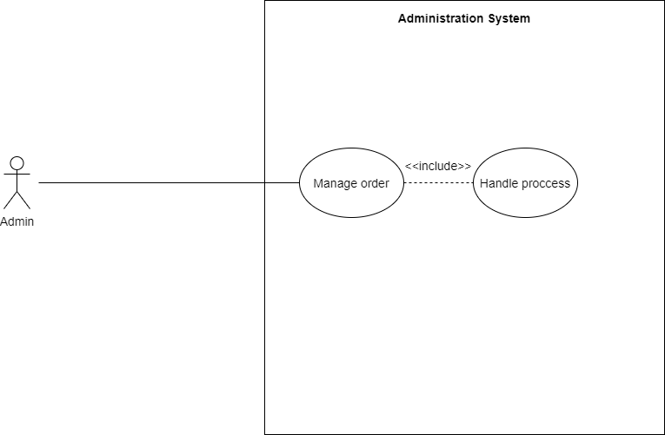

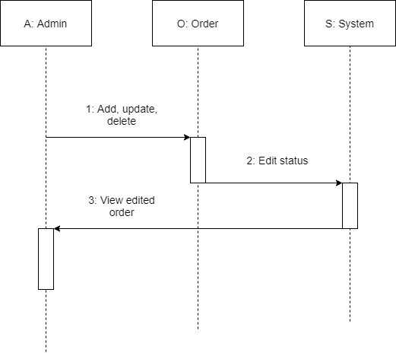

|  |  |  |
| --- | --- | --- |
| **Description** | Admin edits the status in the order then the system will update the status. | |
|  | **Action** | **System responses** |
| **Basic flow** | 1) Add, update, delete | Admin adds, updates, deletes order. |
| 2) Edit status | The system will update status. |
| 3) View edited order | If the system update is successful, it will show back to admin. |
| **Exception** |  |  |

* Manage revenue:

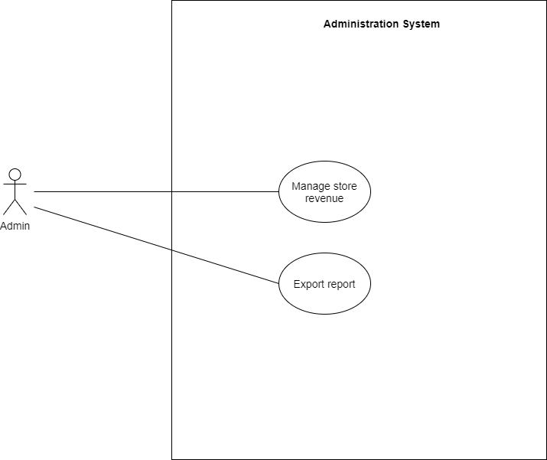

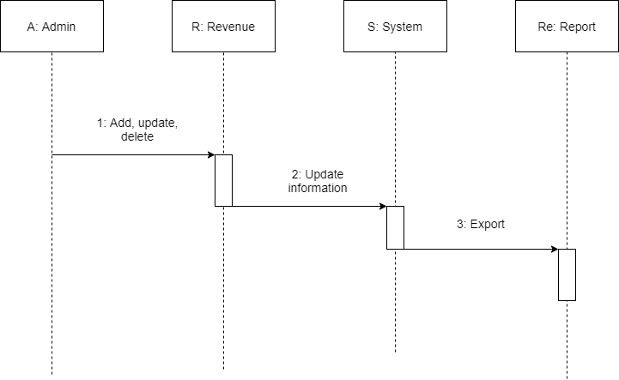

|  |  |  |
| --- | --- | --- |
| **Description** | Admin edits the status in the order then the system will update the status. | |
|  | **Action** | **System responses** |
| **Basic flow** | 1) Add, update, delete | Admin adds, updates, deletes store’s revenue. |
| 2) Update information | The system will update information. |
| 3) Export | Admin can print store’s revenue report. |
| **Exception** |  |  |

## ENTITY RELATIONSHIP DIAGRAM

## TABLE DESIGN

1. Table Cart:

`id` int(11) NOT NULL,

`user_id` int(11) NOT NULL,

`pet_id` int(11) NOT NULL,

`petName` varchar(255) NOT NULL,

`price` decimal(10,2) NOT NULL,

`quantity` int(11) NOT NULL,

`subtotal` decimal(10,2) NOT NULL

2. Table Category:

`id` int(11) NOT NULL,

`name` varchar(30) NOT NULL,

`description` text NOT NULL

3. Table coupon_codes:

`id` int(11) NOT NULL,

`code` varchar(20) NOT NULL,

`discount` int(11) NOT NULL,

`expiry_date` date NOT NULL,

`quantity` int(11) NOT NULL,

`min` int(11) NOT NULL

4. Table coupon_history:

`id` int(11) NOT NULL,

`coupon_id` int(11) NOT NULL,

`user_id` int(11) NOT NULL

5. Table forget_pass:

`id` int(11) NOT NULL,

`user_id` int(11) NOT NULL,

`token` varchar(200) NOT NULL,

`duration` int(11) NOT NULL

6. Table order_:

`id` int(11) NOT NULL,

`cus_id` int(11) NOT NULL,

`pro_id` int(11) NOT NULL,

`codeOrder` int(11) NOT NULL,

`order_date` datetime NOT NULL,

`total` int(11) NOT NULL,

`shipping_address` varchar(50) NOT NULL,

`payment_method` varchar(20) NOT NULL,

`order_status` int(2) NOT NULL

7. Table order_all:

`id` int(5) NOT NULL,

`cus_id` int(5) NOT NULL,

`pro_id` int(5) NOT NULL,

`codeOrder` int(4) NOT NULL,

`order_date` datetime NOT NULL,

`total` int(30) NOT NULL,

`shipping_address` text NOT NULL,

`payment_method` varchar(50) NOT NULL,

`order_status` int(5) NOT NULL

8. Table order_details:

`id` int(11) NOT NULL,

`pro_name` varchar(30) NOT NULL,

`pro_id` int(11) NOT NULL,

`price` int(11) NOT NULL,

`quantity` int(11) NOT NULL,

`codeOrder` int(11) NOT NULL,

`status_ship` int(11) NOT NULL,

`return_the_pet` int(11) DEFAULT NULL

9. Table pets:

`petId` int(11) NOT NULL,

`petName` varchar(30) NOT NULL,

`price` int(10) NOT NULL,

`quantity` int(10) NOT NULL,

`categoryId` int(30) NOT NULL,

`geld_at` date DEFAULT NULL,

`age` int(11) NOT NULL,

`gender` varchar(10) NOT NULL,

`weight` int(5) NOT NULL,

`description` text NOT NULL,

`created_at` date NOT NULL,

`updated_at` date NOT NULL,

`delete_at` date NOT NULL,

`updated_by` date NOT NULL,

`isActive` int(10) NOT NULL,

`daddog` varchar(20) NOT NULL,

`momdog` varchar(20) NOT NULL

10. Table pet_image:

`id` int(11) NOT NULL,

`image` varchar(50) DEFAULT NULL,

`petId` int(11) NOT NULL

10. Table product_thumbnail:

`id` int(11) NOT NULL,

`id_product` int(11) NOT NULL,

`thumbnail` varchar(50) NOT NULL

11. Table return_the_pet:

`id` int(11) NOT NULL,

`description` text NOT NULL,

`image` text NOT NULL,

`codeOrder` int(11) NOT NULL,

`status_return` int(11) NOT NULL,

`pro_id` int(11) NOT NULL

12. Table silder:

`id` int(11) NOT NULL,

`content` varchar(100) NOT NULL,

`description` text NOT NULL,

`image` text NOT NULL

13. Table user:

`user_id` int(11) NOT NULL,

`firstname` varchar(30) NOT NULL,

`lastname` varchar(30) NOT NULL,

`country` varchar(20) NOT NULL,

`address` varchar(50) NOT NULL,

`phone` varchar(20) NOT NULL,

`zip` varchar(30) NOT NULL,

`email` varchar(50) NOT NULL,

`password` varchar(255) NOT NULL,

`token` varchar(200) NOT NULL

13. Table user_admin:

`id` int(11) NOT NULL,

`email` varchar(50) NOT NULL,

`phone` int(11) NOT NULL,

`Address` varchar(100) NOT NULL,

`password` varchar(100) NOT NULL,

`role` int(11) NOT NULL,

`status` int(11) NOT NULL,

`token` varchar(200) NOT NULL

## TASK SHEET REVIEW 2

|  |  |  |  |  |  |  |  |
| --- | --- | --- | --- | --- | --- | --- | --- |
| **Project Ref. No.:** | | **Project Title:** | **Activity Plan Prepared By:** | **Date of Preparation of Activity Plan:** | | | |
| **Sr.No.** | **Task** | **Actual Start Date** | **Actual Days** | **Team Mate Names** | **Status** |
| 1 | DFD (Data Flow Diagram) | **Dog Shop** | Trương Tấn Phát, Nguyễn Hoàng Gia Phúc | 13/5/2023 | 1 | Nguyễn Hoàng Gia Phúc | 100% |
| 2 | Use Case Diagram and Sequence Diagram | 13/5/2023 | 1 | Nguyễn Hoàng Gia Phúc | 100% |
| 3 | ERD (Entity Relationship Diagram) | 13/5/2023 | 1 | Trương Tấn Phát | 100% |
| 4 | Table Design | 13/5/2023 | 1 | Nguyễn Hoàng Gia Phúc | 100% |

|  |  |
| --- | --- |
| **Date: 12/06/2023** | |
| Signature of Instructor:  **Mr. Nguyen Ha Vy** | Signature of Team Leader:  **Truong Tan Phat** |

# 

# **REVIEW 3**

## DESIGN

## Admin

**1. Login**

1: email

2: password

3: forge-Password

4: sigh in

3

2

1

|  |  |  |  |  |  |
| --- | --- | --- | --- | --- | --- |
| **No** | **Name** | **Type** | **Validation** | **Description** | **Status** |
| 1 | Email | Textbox | Input not blank | Enter Admin’s ID | Enable |
| 2 | Password | Textbox | Input not blank | Enter Admin’s password | Enable |
| 3 | SignIn | Button |  | Click to login | Enable |

**2.NavBar**

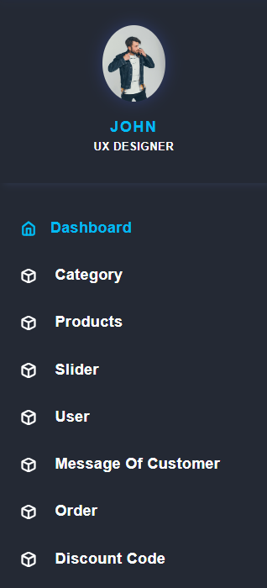

1

2

3

4

5

6

7

8

|  |  |  |  |  |  |
| --- | --- | --- | --- | --- | --- |
| **No** | **Name** | **Type** | **Validation** | **Description** | **Status** |
| 1 | dashboard | Link |  | Click on to go to Admin | Enable |
|  |  |  |  |  |  |
| 2 | Categories | Link |  | Click on to go to Categories Product | Enable |
| 3 | Manage Products | Link |  | Click on to go to Products Tab | Enable |
| 4 | slider | Link |  | Click on to go to slider | Enable |
| 5 | user | Link |  | Click on to go to Customer | Enable |
| 6 | Message of customer | Link |  | Click on to go Message of customer | Enable |
| 7 | Order | Link |  | Click on to go order | Enable |
| 8 | Discount code | Link |  | Click on to go discount code | Enable |

1 2 3

**3.Admin Page**

7 8 9

4 5 6

Show product :

|  |  |  |  |  |  |
| --- | --- | --- | --- | --- | --- |
| **No** | **Name** | **Type** | **Validation** | **Description** | **Status** |
| 1 | close | Button |  | Click to close | Enable |
| 2 | See all product | Link |  | Show all product | Enable |
| 3 | delete | Button |  | Click to delete | Enable |

Show slider :

|  |  |  |  |  |  |
| --- | --- | --- | --- | --- | --- |
| **No** | **Name** | **Type** | **Validation** | **Description** | **Status** |
| 4 | close | Button |  | Click to close | Enable |
| 5 | See all slider | Link |  | Show all slider | Enable |
| 6 | delete | Button |  | Click to delete | Enable |

Show category :

|  |  |  |  |  |  |
| --- | --- | --- | --- | --- | --- |
| **No** | **Name** | **Type** | **Validation** | **Description** | **Status** |
| 4 | close | Button |  | Click to close | Enable |
| 5 | See all category | Link |  | Show all category | Enable |
| 6 | delete | Button |  | Click to delete | Enable |

**4.Manage Categories**

1

2

3

|  |  |  |  |  |  |
| --- | --- | --- | --- | --- | --- |
| **No** | **Name** | **Type** | **Validation** | **Description** | **Status** |
| 1 | Add | Button |  | Click on to go to “Create New Categories” page | Enable |
| 2 | Edit | Link |  | Click on go to Edit Categories | Enable |
| 3 | Delete | Button |  | Click on to go to “delete Categories” page | Enable |

**5.Manage Products**

1

2

3

2 3

|  |  |  |  |  |  |
| --- | --- | --- | --- | --- | --- |
| **No** | **Name** | **Type** | **Validation** | **Description** | **Status** |
| 1 | Add Products | Button |  | Click on to go to “Create New Products” page | Enable |
| 3 | Edit | Link |  | Click on to go to “Update ” page | Enable |
| 4 | Delete | Button |  | Click to remove product | Enable |

**6.Manage Slider**

1

2

3

2 3

|  |  |  |  |  |  |
| --- | --- | --- | --- | --- | --- |
| **No** | **Name** | **Type** | **Validation** | **Description** | **Status** |
| 1 | Add slider | Button |  | Click on to go to “Create New slider” page | Enable |
| 3 | Edit | Link |  | Click on to go to “Update ” page | Enable |
| 4 | Delete | Button |  | Click to remove product | Enable |

**7.Manage order**

1

2

3

|  |  |  |  |  |  |
| --- | --- | --- | --- | --- | --- |
| **No** | **Name** | **Type** | **Validation** | **Description** | **Status** |
| 1 | view | Link |  | Show order detail | Enable |

**8.Multi order detail**

## User

1 2 3 4 5 6 7

**1.HomePage**

2.1

2.2

|  |  |  |  |  |  |
| --- | --- | --- | --- | --- | --- |
| **No** | **Name** | **Type** | **Validation** | **Description** | **Status** |
| 1 | Home | Link |  | Click on to go to Home Page | Enable |
| 2 | shop | hover |  | See all category | Enable |
| 2.1 | All | Link |  | Click on to go to shop Page | Enable |
| 2.2 | Category | Link |  | Click to see each type in the shop | Enable |
| 3 | About | Link |  | Click on to go to about Page | Enable |
| 4 | Blog | Link |  | Click on to go to blog Page | Enable |
| 5 | Contact | Link |  | Click on to Contact Page | Enable |
| 6 | Cart | Link |  | Click on to Cart Page | Enable |
| 7 | Acccount | Link |  | Click on to Acccount Page | Enable |
|  |  |  |  |  |  |

**2.Product Page**

**3.Cart**

**4.Payment**

**6.Login Page**

**7.Register Page**

**8.Forgot Password**

**9.Footer**

**10.single product**

TASK SHEET REVIEW 3

|  |  |  |
| --- | --- | --- |
| **Task** | **Team Mate Names** | **Status** |
| Category (Insert,update,delete). | **Front-End**  Trương Tấn Phát  **Back-End** | Done |
| Product (Insert,update,delete,upload image)  Single product. | Done |
| Search by name, age, breed. | Done |
| Slider (Insert,update,delete,upload image). | Done |
| Order (View, edit status, send mail to customers both backend and frontend). | Done |
| Pay online with paypal | Done |
| Discount code | Diệp Thái Thiên Long | Done |
| About | Done |
| Mini game | Done |
| User (Login, Logout, Register) | Nguyễn Hoàng Gia Phúc | Done |
| Cart, Update Quantity | Done |
| Change password | Done |
| Forgot password | Done |
| Change user information | Done |
| Admin (boss, staff,mess, …) | Done |
| Contact | Done |

s